**Intel College Excellence Program   
Project Synopsis**

**“Digital Clock”**

|  |  |  |  |
| --- | --- | --- | --- |
| **Team member’s detail** | | | |
| **S.No.** | **Participant Name** | **Mobile No.** | **Email ID** |
| 1 | Chava Likhith | 9550240270 | ***Chavalikhith70@gmail.com*** |
| **Faculty(college) mentor detail** | | | |
| **S.No.** | **Mentor Name** | **Mobile No.** | **Email ID** |
| 1 | Dr. Praveen Malik | 9719437711 | ***Praveen.23314@lpu.co.in*** |
| **College/University Name** | | | |
| ***Lovely Professional University*** | | | |

**BACKGROUND**

Creating a digital clock using a 555 timer, a 7411 IC, a 4026 IC, a 7-segment common cathode display, along with capacitors, resistors, and a voltage source involves a systematic approach to generate clock signals, divide them into seconds, minutes, and hours, and display the time on a 7-segment display.

The 555 timer is set up in astable mode to generate clock pulses. This timer generates a continuous square wave output whose frequency is determined by the values of resistors and capacitors connected to it. The clock pulses from the 555 timer are fed into the clock input (CLK) of the 4026 IC. The 4026 IC is a CMOS IC that acts as a decade counter/divider. It sequentially counts the incoming clock pulses and advances its output in response to each pulse. The output pins (Q0-Q9) of the 4026 IC correspond to the segments of the 7-segment display. These output pins are connected to the input pins of the 7-segment display to illuminate the appropriate segments for each digit based on the count from the 4026 IC. The 7411 IC (or similar logic gates) combines these outputs to control the segments of the 7-segment display efficiently.

For a successful implementation, accurate selection of components, proper wiring, correct values of resistors and capacitors, and efficient utilization of logic gates are crucial. Simulation tools like Proteus enable you to test and verify the functionality of the circuit before actual hardware implementation.

**PROBLEM IDENTIFICATION**

In a digital clock project using a 555 timer, 7411 IC, 4026 IC, a 7-segment common cathode display, capacitors, resistors, and a voltage source, several potential problems or challenges might arise during the design, implementation, or simulation phases. There are some common issues to watch out like Timing and Frequency Accuracy, Circuit Stability and Noise, Logic Circuit Design, Segment Display, Simulation Accuracy.

**PROPOSED SOLUTION**

The Solutions to address the identified problems in a digital clock project using a 555 timer, 7411 IC, 4026 IC, a 7-segment common cathode display, capacitors, resistors, and a voltage source:

**Timing and Frequency Accuracy:** Use components with tighter tolerances for resistors and capacitors to improve accuracy. Employ a variable resistor (potentiometer) in parallel with a fixed resistor to fine-tune the frequency.

**Circuit Stability and Noise:** Choose capacitors with low tolerance and suitable capacitance values to stabilize the voltage. Add bypass capacitors across the power supply lines to reduce high-frequency noise.

**Logic Circuit Design:** Double-check wiring and use proper logic diagrams to ensure accurate connections. Simulate the logic circuit in software (like Proteus) to verify the design before implementation.

**Segment Display:** Calculate and use appropriate current-limiting resistors for each segment of the 7-segment display based on the datasheet specifications. Ensure proper connections and verify the display's specifications to avoid overloading or damaging the segments.

**Simulation Accuracy:** Use accurate models of components available in the simulation software. Verify simulation settings, such as signal levels and timing parameters, to match real-world conditions as closely as possible.

**COMPONENTS REQUIRED**

*If we want to implement the digital clock in proteus these are the components required:*

*1.* *7SEG-COM-CATHODE*

*2.* 555

3. 4026

4. 7411

5. C1206C183J2RACTU

6. METALFILM470R

**CIRCUIT DIAGRAM & DESCRIPTION**

*The digital clock circuit is designed to display time in hours, minutes, and seconds using a 7-segment display. The circuit utilizes various integrated circuits and components to generate clock pulses, divide them into time intervals, and drive the 7-segment display to represent the time.*

**Clock Pulse Generation:** The 555 timer generates clock pulses in astable mode. The frequency of these pulses determines the time accuracy. Resistors and capacitors in the 555-timer circuit define the frequency of the clock pulses.

**Time Division with 4026 IC:** Clock pulses from the 555-timer are fed into the clock input (CLK) of the 4026 IC. The 4026 IC sequentially counts these pulses, dividing them into time intervals for hours, minutes, and seconds.

**Driving the 7-Segment Display:** The output pins (Q0-Q9) of the 4026 IC are connected to the input pins of the 7-segment display. The outputs correspond to segments of the display, illuminating the appropriate segments to represent the digits of hours, minutes, and seconds.

**Logic Control with 7411 IC:** The 7411 IC, functioning as 3-input AND gates, combines the outputs of the 4026 IC to efficiently control the segments of the 7-segment display.

**Accuracy and Time Representation:** Accuracy of time representation on the display is determined by the clock pulse frequency and the division logic of the 4026 IC. The combined segments of the 7-segment display represent the current time.

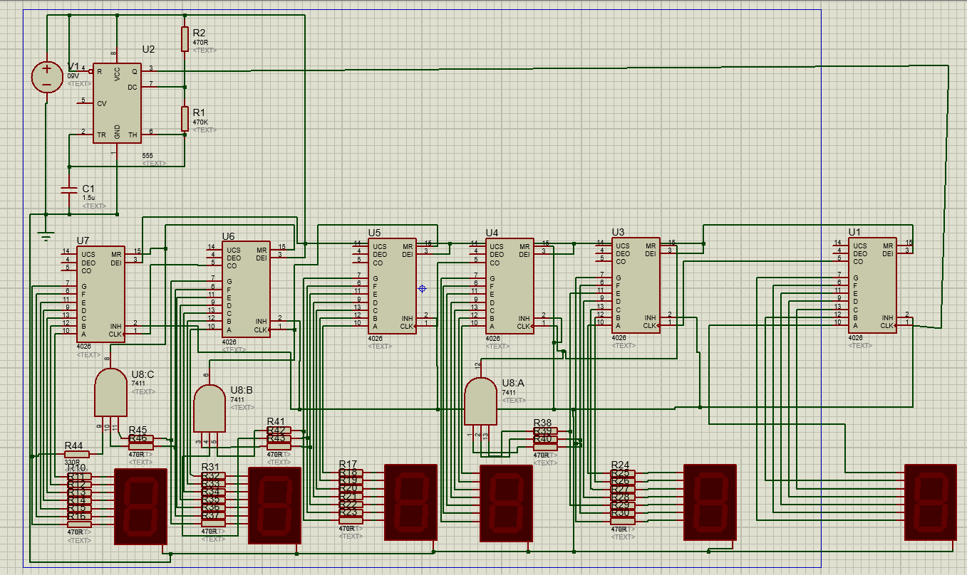

**FUTURE SCOPE**

The digital clock project using a 555 timer, 7411 IC, 4026 IC, a 7-segment common cathode display, capacitors, resistors, and a voltage source offers various opportunities for future development and enhancement like Real-Time Clock (RTC) Integration, Microcontroller-Based Control, Temperature and Humidity Sensors, Wireless Connectivity, LED Matrix Displays, User Interface Enhancements.

**CONCLUSION**

The digital clock circuit combines the functionalities of various ICs and components to generate accurate clock signals, divide them into time intervals, and display the time on a 7-segment display. This project demonstrates the application of basic digital logic and integrated circuits in creating a functional digital timekeeping device.

**REFERENCES**

*<* *>*

**THANK YOU TO FICE**